CR-05 - Goals and Outcomes
Progress the jurisdiction has made in carrying out its strategic plan and its action plan. 91.520(a)
This could be an overview that includes major initiatives and highlights that were proposed and executed throughout the program year.

A steady year of working toward our goals took a sudden turn in early May when two tornadoes ran through the City of Portage, followed by another high windstorm that tore through another part of the city, ending the fiscal year with urgency to assure people were adequately housed and had necessary amenities to keep their families safe and sound. With slightly reduced CDBG funding program goals were reduced, though the outcome was much better than anticipated! We adjusted in housing rehabilitation to reduce the amount of assistance to one necessary project per homeowner, stretching the dollars to more homeowners. Thirty-three purchase orders were created for home improvement projects at 15 homes allowing homeowners to live in safer, more energy efficient homes. In tandem with the City’s CDBG program, the second Kalamazoo County housing rehabilitation grant was awarded, adding 24 more purchase orders for home improvement projects at 17 more homes. A Kalamazoo County Emergency housing rehabilitation program grant was received that allows work to mobile homes in addition to homeowner occupied homes resulting in 22 purchase orders and 18 emergency repair projects. The neighborhood improvement program had a stellar year and really came to the table assisting people after the storms addressing blighting influences and upset neighbors in low- and moderate-income neighborhoods, assisting 420 more cases than the prior year. Portage Community Center operated a transportation assistance program for low-income portage citizens assisting them to get to work and necessary medical appointments assisting them to stay in their homes . They more than doubled their goal helping 133 low-and moderate-income people. A substantial plan amendment allowed Houring Resources Inc. to continue to prevent eviction and reduce homelessness by supporting families affected from the pandemic by providing rent and utility forgiveness attributed to COVID-19.
NOTE: IDIS did not create fields in Table 1 for Public Services Indicator to correctly report 60 Low/Moderate persons were expected and 133 actually were served, as indicated in the narrative above. IDIS did create these fields for Table 2. When the CAPER downloads, the information in Table 1 for Public Services needs to be moved to the last Non-Homeless Special Needs (for Low/Moderate Income Households Benefit). These were manually corrected in the downloaded WORD document which was presented during the Public Comment period.
Comparison of the proposed versus actual outcomes for each outcome measure submitted with the consolidated plan and explain, if applicable, why progress was not made toward meeting goals and objectives. 91.520(g)
Categories, priority levels, funding sources and amounts, outcomes/objectives, goal outcome indicators, units of measure, targets, actual outcomes/outputs, and percentage completed for each of the grantee’s program year goals.

Goal | Category | Source / Amount | Indicator | Unit of Measure | Expected – Strategic Plan | Actual – Strategic Plan | Percent Complete | Expected – Program Year | Actual – Program Year | Percent Complete
Administration/Planning | Program Administration | CDBG: $ | Other | Other | 0 | 0 | 80% | 0 | 0 | 80%
Affordable Owner Housing | Affordable Housing | CDBG: $ | Homeowner Housing Added | Household Housing Unit | 5 | 0 | 0.00% | 0 | 0 | 100%
Affordable Owner Housing | Affordable Housing | CDBG: $ | Homeowner Housing Rehabilitated | Household Housing Unit | 60 | 51 | 85.00% | 8 | 15 | 187.50%
Affordable Owner Housing | Affordable Housing | CDBG: $ | Direct Financial Assistance to Homebuyers | Households Assisted | 15 | 2 | 13.33% | 0 | 0 | 100%
Affordable Renter Housing | Affordable Housing | CDBG: $ | Rental units rehabilitated | Household Housing Unit | 5 | 0 | 0.00% | 0 | 0 | 100%
Neighborhood Improvement | Non-Housing Community Development | CDBG: $ | Housing Code Enforcement/Foreclosed Property Care | Household Housing Unit | 1750 | 787 | 44.97% | 300 | 1601 | 533.67%
Non-Housing Community Development | Non-Housing Community Development | CDBG: $ | Public Facility or Infrastructure Activities other than Low/Moderate Income Housing Benefit | Persons Assisted | 0 | 0 | 0.00 | 0 | 0 | 100%
Non-Housing Community Development | Non-Housing Community Development | CDBG: $ | Other | Other | 1 | 0 | 0.00% | 0 | 0 | 100%
Public Services | Non-Homeless Special Needs | CDBG: $ | Public service activities other than Low/Moderate Income Housing Benefit | Persons Assisted | 0 | 0 | 0.00% | 0 | 0 | 100%
Public Services | Non-Homeless Special Needs | CDBG: $ | Public service activities for Low/Moderate Income Housing Benefit | Households Assisted | 20000 | 3146 | 15.73% | 60 | 133 | 221.67%
Table 1 - Accomplishments – Program Year & Strategic Plan to Date

Assess how the jurisdiction’s use of funds, particularly CDBG, addresses the priorities and specific objectives identified in the plan, giving special attention to the highest priority activities identified.
1. Homeowner housing rehabilitation has 51 of its 5-year goal of 60 completed. Housing rehabilitation historically is a well utilized program, especially since the pandemic, when the cost of materials increased making necessary repairs very difficult or impossible for homeowners. It is anticipated CDBG funds will allow for completion of 9 or more homeowner rehabilitation projects. Construction costs remain high. The City of Portage initiated extensive outreach to homeowners through a direct mail flyer bringing awareness of the program, as a result of leveraging CDBG funds with other sources (Kalamazoo County and MSHDA).
2. Down payment assistance has a five-year goal of 15, where only 2 have been completed. The funding provided was not large enough to buy down the cost of homes, though we applied and received a grant from Kalamazoo County, and are building new homes, that includes a down payment component. It is anticipated 4 or more people will utilize that down payment assistance program in the next year.
3. The neighborhood improvement program helps to eliminate blight and zoning violations in low/moderate areas in the City of Portage. This past year’s storms escalated the work needed to be sympathetic, yet encourage quality, efficient clean-up of damaged properties. The program exceeded the 5-year Consolidated Plan goal and anticipates 300 more cases this year, even with declined new low-moderate-income census areas.
4. Portage Community Center provides public services to low- and moderate-income citizens in the City of Portage addressing needs to prevent homelessness. The amount of CDBG funding has declined to a level where only their transportation assistance is funded with a goal of 60 people. They receive other funding support for emergency assistance in the way of food, clothing, and utility assistance. With the storms, assistance with insurance deductibles has become an increasing situation. The five-year goal is 20,000 individuals, which cannot be met given the amount of funding provided. Portage Community Center assisted 133 persons last year, which was more than double their goal for the transportation program.

CR-10 - Racial and Ethnic composition of families assisted
Describe the families assisted (including the racial and ethnic status of families assisted). 91.520(a)

 | CDBG
White | 98
Black or African American | 114
Asian | 0
American Indian or American Native | 4
Native Hawaiian or Other Pacific Islander | 0

Total | 216

Hispanic | 12
Not Hispanic | 212

Table 2 – Table of assistance to racial and ethnic populations by source of funds

Narrative
In addition to the races listed above the following races were assisted for a total of 224.
6 Black or African American and White
2 American Incian & Black or African American

CR-15 - Resources and Investments 91.520(a)
Identify the resources made available
Source of Funds | Source | Resources Made Available | Amount Expended During Program Year
CDBG | public - federal | 209,795 | 105,674
Table 3 - Resources Made Available

Narrative
Table 3 summarizes the resources available during the program year compared to actual expenditure.
CDBG funds were spent on activities as identified in the FY23-24 AAP. They include an owner-occupied home repair program, a neighborhood improvement program, emergency transportation assistance, administration and fair housing services. They include the allocation of $209,795 plus $50,000 program income. The CDBG CV funds were spent as a response to COVID-19 by assisting to prevent homelessness or eviction through rent and utility assistance through Housing Resources, Inc., a subrecipient.
Kalamazoo County funds were spent on an owner-occupied home repair and emergency home repair program. The City of Portage local general funds were spent through subrecipients on critical home repairs for elderly owners, a run-away youth shelter, food pantry organizations, handicapped ramp installations, human services referrals, a youth development program, emergency utility and rent assistance, English as a second language and literacy tutoring, clothing assistance, a medical equipment lending program, sexual and domestic violence victim support, emergency housing & utility assistance and human trafficking victim support.

Identify the geographic distribution and location of investments
Target Area | Planned Percentage of Allocation | Actual Percentage of Allocation | Narrative Description
Citywide | 72 | 85 | All other programs
Low/Mod Neighborhoods | 28 | 15 | Neighborhood Improvement Program
Table 4 – Identify the geographic distribution and location of investments

Narrative
The table above reflects the allocation of CDBG funds.
100% of the CDBG CV funds were disbursed to low-income household’s city wide.
100% of the Kalamazoo County grant funds were distributed to low- and moderate-income households city wide.
100% of the City of Portage funds to subrecipients were distributed to households or individuals that live in the City of Portage.
Leveraging
Explain how federal funds leveraged additional resources (private, state and local funds), including a description of how matching requirements were satisfied, as well as how any publicly owned land or property located within the jurisdiction that were used to address the needs identified in the plan.
The City of Portage has been able to leverage the CDBG funding and is continually looking for other funding sources to support the availability of safe and affordable housing for all.
A second Kalamazoo County grant for housing rehabilitation was received for FY23-24 for home repairs and energy efficient improvements to single family homes in the City of Portage. An emergency home repair program grant for use specifically on items that are a threat to people’s health and safety was also received totaling $324,210 that more than matched the CDBG allocation.
A MSHDA NEP grant for $50,000 to work in targeted neighborhood was received but has not been expended for exterior improvements to homeowners’ homes in a low-income neighborhood.
A Kalamazoo County grant of $3,000,000, with $1,000,000 per year allocated over three years, was received to assist with creation of 45 new attainable single-family homes for sale in the City of Portage supporting persons in the 80 – 120% of area median income range. This project has not yet begun construction though much of the planning is complete.
To support the affordable purchase of the new workforce homes, a Kalamazoo County grant of $100,000 was awarded for down payment assistance specific to the new homes and is expected to support assistance to 4 or more new homeowners.
The City of Portage, Human Services Board (HSB) centered their focus on housing, asking human service providers to increase housing-related efforts to not only assist residents with their direct service needs, but also to refer people to programs and agencies that can help them better their overall situations in the long run. The retooled the funding application prioritized funding to organizations that specifically address obtaining and staying in housing. For a second time, this resulted in several first-time applications from new organizations, including supportive senior home repairs for an autistic home, basic skills to allow handicapped people to be as independent as they can, and a shoe program that supports new shoes for handicapped and elementary school children in Portage, MI. Another organization is completing home repairs and alterations using volunteer labor supervised by licensed professionals. Portage City Council approved HSB-recommended FY2023-2024 grant allocations to eleven non-profit organizations, providing $205,400 to leverage funds in support of housing and homelessness prevention.

CR-20 - Affordable Housing 91.520(b)
Evaluation of the jurisdiction's progress in providing affordable housing, including the number and types of families served, the number of extremely low-income, low-income, moderate-income, and middle-income persons served.

 | One-Year Goal | Actual
Number of Homeless households to be provided affordable housing units | 0 | 0
Number of Non-Homeless households to be provided affordable housing units | 60 | 85
Number of Special-Needs households to be provided affordable housing units | 0 | 0
Total | 60 | 85
Table 11 – Number of Households

 | One-Year Goal | Actual
Number of households supported through Rental Assistance | 0 | 0
Number of households supported through The Production of New Units | 0 | 0
Number of households supported through Rehab of Existing Units | 8 | 15
Number of households supported through Acquisition of Existing Units | 0 | 0
Total | 8 | 15
Table 12 – Number of Households Supported

Discuss the difference between goals and outcomes and problems encountered in meeting these goals.
The City of Portage receives less and less CDBG funding making it difficult to meet the numbers in the Consolidated Plan, however we have become successful in leveraging other funding sources to continue meeting and exceeding goals. It’s a challenge to learn new program platforms and reporting. Our small community finance department continues to be challenged by the multiple funding sources, reporting requirements and keeping loans separate while utilizing one overall program. Despite the challenges, the City of Portage and our not-for-profit agencies are successful in providing Portage citizens with the help they are seeking. Our success is the result of numerous marketing efforts including monthly publication in the Portager newsletter that is distributed to each house and apartment in the City of Portage. We network and meet regularly with agencies to help each other find necessary resources. We hold a Human Services open house that includes 24- 30 human service providers. The open house allows us to network with each other as well as the public, and better understand each organization’s offerings.
Discuss how these outcomes will impact future annual action plans.
This is the last year of our Consolidate Plan providing the opportunity to review and create new goals. With continued dwindling CDBG funds, the impact on future AAP’s become more focused on the greatest need, versus meeting all the needs that the general fund and other sources of funding will fulfill. Depending on the ability for the City of Portage to continue identifying additional funding, down payment assistance, emergency repairs and even the public service programs will likely be shifted out of CDBG to allow more home repair projects. The county funded millage grant changes its offerings annually and continues to be a valuable leverage to the CDBG funds providing support for down payment assistance and new workforce housing.
Include the number of extremely low-income, low-income, and moderate-income persons served by each activity where information on income by family size is required to determine the eligibility of the activity.

Number of Households Served | CDBG Actual | HOME Actual
Extremely Low-income | 155 | 0
Low-income | 57 | 0
Moderate-income | 21 | 0
Total | 233 | 0
Table 13 – Number of Households Served

Narrative Information
Table 13 above includes the number of extremely low-income, low-income, and moderate-income persons served by the CDBG housing rehabilitation, transportation assistance and COVID rapid rehousing and utility assistance program activities during FY 2023-24. All households must be determined income eligible prior to initiating participation in a CDBG housing assistance program, and household income must not exceed 80% of the area median income (AMI) for Kalamazoo County, as determined annually by HUD. A household with between 0%-30% of AMI is considered extremely low-income; a household with an income between 31%-50% AMI is considered low-income, whereas a household between 51%-80% AMI is considered moderate income.

CR-25 - Homeless and Other Special Needs 91.220(d, e); 91.320(d, e); 91.520(c)
Evaluate the jurisdiction’s progress in meeting its specific objectives for reducing and ending homelessness through:
Reaching out to homeless persons (especially unsheltered persons) and assessing their individual needs
The City of Portage has endorsed the Kalamazoo County Continuum of Care (CoC) ongoing efforts to address homelessness and has allocated CDBG, CDBG-CV Program, and General Fund monies towards homeless services. In addition to services for homeless people, funding was provided to the Gryphon Place to help provide a 2-1-1 service, which is a portal to specialized support services related to homelessness prevention (such as the Eviction Diversion Program). Catholic Charities operates a runaway youth shelter while providing counseling to the family and the Fair Housing Center of Southwest Michigan services all City of Portage residents.
Addressing the emergency shelter and transitional housing needs of homeless persons
The City of Portage attempts to address emergency shelter and transitional housing needs as noted above, as well as through the annual Kalamazoo County revenue generated by the “Housing for All” millage, which supports most Portage residents. Grants from the CDBG Program and General Fund combined awarded during FY 2023-24 to help keep people in their homes longer and prevent homelessness. A CP substantial plan amendment was completed to reallocate dollars to prevent homelessness in response to the pandemic, meeting the needs of people at risk or experiencing homelessness. A significant number of services help persons/families living at the poverty level and/or those persons/families that are currently homeless or in danger of becoming homeless. Agencies funded include:
• Catholic Charities - The ARK: provided youth shelter, transitional and permanent housing, and counseling services to protect children and reunite families when possible. General Fund: $10,000.
• Housing Resources Incorporated: aided homeless persons and persons in danger of becoming homeless in order to secure housing. General Fund: $25,000.
• YWCA: provided emergency shelter, transitional and permanent housing for women and their children who are victims of domestic and/or sexual abuse. General Fund: $20,000.
• Portage Community Center: provided a variety of services including emergency assistance (food, clothing, utility shut-off payments, etc.), transportation assistance, and youth recreation scholarships. CDBG Fund: $5,000.00. Also provided host agency programs, youth development programs, information/referrals amongst other services. General Fund: $67,000.
• Twelve Baskets: Free food distribution at the Portage location and free food distribution, and a free store for household clothing and household items. General Fund: $20,000.
• Gryphon Place: 2-1-1 Referral Program assisting in making needed connections to City human services including suicide prevention, food, rent, housing, and emergency assistance. General Fund: 4,000.
• Kalamazoo Literacy Council: provided literacy education to Portage residents: $5,000.
Helping low-income individuals and families avoid becoming homeless, especially extremely low-income individuals and families and those who are: likely to become homeless after being discharged from publicly funded institutions and systems of care (such as health care facilities, mental health facilities, foster care and other youth facilities, and corrections programs and institutions); and, receiving assistance from public or private agencies that address housing, health, social services, employment, education, or youth needs
The city advocates and assists people in making connections to human service agencies that provide a variety of assistance, which include ageing population where assisted and supportive living is a big cost, homelessness prevention efforts and housing contacts. In addition, the City actively participates in the CoC, which has developed policies and procedures intended to improve the outcome of persons with disabilities or discharged from various institutions and prevent further homelessness.
Helping homeless persons (especially chronically homeless individuals and families, families with children, veterans and their families, and unaccompanied youth) make the transition to permanent housing and independent living, including shortening the period of time that individuals and families experience homelessness, facilitating access for homeless individuals and families to affordable housing units, and preventing individuals and families who were recently homeless from becoming homeless again
Housing and housing services are a very high focus for the Portage City Council. In addition to the CDBG Entitlement funding, the City of Portage general fund supports many non-profit organizations focused on housing.
- Housing Resources Inc. is a local agency that is a master at assisting homeless people. They are resourceful and provide counseling in addition to financial assistance that adds to their success of preventing reoccurrences. HRI researched housing options including creating a small house POD community with a central kitchen and bathing/bathroom facility. They purchased PODS, then ran into a site issue, which delayed motion for a while. Portage is so thankful for the premium programming they provide to this special population.
- Catholic Charities operates the ARK program providing a unique program for youth that have run-away from home or find themselves homeless for some reason. They provide family counseling to work through situations and replace the youth with their family or seek alternate housing should that be the necessary outcome.
- Gryphon Place is a 2-1-1 help line call center extremely versed in suicide prevention in addition to being a community resource to meet other needs including homelessness.
- Kalamazoo Literacy Council specializes in tutoring non-English speaking residents, or persons needing to fine-tune the English language to prevent homelessness, apply for work, and to better themselves overall with the English language.
- Multiple food pantries are assisting people with nourishment so they can be productive at work with protein and fresh fruit and vegetables, keeping more of their income for housing.

CR-30 - Public Housing 91.220(h); 91.320(j)
Actions taken to address the needs of public housing
In 2002 Kalamazoo County did establish a Public Housing Commission (PHC) that provides tenant-based rental assistance within Kalamazoo County, which is in addition to rental assistance provides within Kalamazoo County via MSHDA. In 2020, voters approved a 0.75-mill property tax covering eight years, from December 2021 to December 2028, to provide rental subsidies, permanent housing, and other supportive services for Kalamazoo County residents, including those who reside in Portage. The increased millage rate generates approximately $6.3 million annually. The City of Portage has been successful in applying for, and receiving, grant funds through this funding source for the Home Repair Program, Emergency Home Repair Program, Portage Road Workforce Housing Development Program, and Workforce Housing Down Payment Assistance Program.
Actions taken to encourage public housing residents to become more involved in management and participate in homeownership
Portage City staff regularly advocate for ownership in lieu of paying rent by referring people to Kalamazoo Neighborhood Housing Services (KNHS) to participate in their homeownership counseling class and mentoring program. KNHS homeowner counseling program provides every opportunity for success by educating people in all aspects of being a homeowner. KNHS employs HUD-certified professionals that assist people, mostly single female parents, in budget counseling, building a down payment, understanding a mortgage, saving for home repairs, taxes, and insurance. The counseling class program offers education to assist potential owners in making a good decision to become a homeowner. Several contacts and referrals were provided to Portage residents connecting them to the KNHS program. Ongoing communication with area non-profits and organizations about programs and organizations helps provide referrals to public housing residents to make the best connections to fit their needs. City of Portage also regularly advocates for existing homeowners to seek budget counseling assistance to consolidate debt when appropriate and plan for housing repairs.
Actions taken to provide assistance to troubled PHAs
Not Applicable.

CR-35 - Other Actions 91.220(j)-(k); 91.320(i)-(j)
Actions taken to remove or ameliorate the negative effects of public policies that serve as barriers to affordable housing such as land use controls, tax policies affecting land, zoning ordinances, building codes, fees and charges, growth limitations, and policies affecting the return on residential investment. 91.220 (j); 91.320 (i)
The city continues to support efforts to facilitate affordable housing including a tax abatement or Payment in Lieu Of Taxes (PILOT), support for MSHDA low-income housing tax credits (LIHTC), competitive permit fees, low water and sewer rates, small lot single-family residential development, high density residential land use, and speed to permitting, among others. The City of Portage has changed policies to allow special assessment payments to be spread over a 20-year term for completion of city water hook-up fees, versus up-front payment. Special assessment payments will be added to a person’s tax bill, which will allow greater opportunity to hook up to city water.
Actions taken to address obstacles to meeting underserved needs. 91.220(k); 91.320(j)
A second human services organization open house was held, and will annually continue, to assist both the public and service providers in understanding the availability of assistance to help meet the needs of underserved populations. The City of Portage financially supports the 211-referral program. Each program carried out by the City of Portage during the program year is intended to assist underserved Portage residents. Gaps are identified and new programs or policies are created to assist, such as paying the assessment to hook up to public water or sewer over a 20-year term.
Actions taken to reduce lead-based paint hazards. 91.220(k); 91.320(j)
Efforts to educate the public and test and address lead-based paint hazards are undertaken in conjunction with the City of Portage CDBG Housing Rehabilitation Program and MSHDA funded projects. Identified hazards are addressed as part of the overall project in compliance with federal regulations. Flyers are located within the Community Development Office and testing organizations are always referred to families, homeowners and renters.
Actions taken to reduce the number of poverty-level families. 91.220(k); 91.320(j)
Referral, referral, referral! The human services board has focused on identifying programs and sharing resources with the community. Human service organizations are asked to not only do what they do, but to go beyond and refer residents as best as possible to other organizations that can assist in making their lives easier. The City allocated CDBG and General Fund resources to organizations addressing the needs of residents and families living at or below poverty. Housing assistance programs, public human services and tax exemptions, veterans’ property tax exemptions, poverty property tax exemptions are in-place examples of actions taken during the program year. Beyond this, the referral initiative encourages cross-referral between agencies as well.
Actions taken to develop institutional structure. 91.220(k); 91.320(j)
The City of Portage Department of Community Development administers the CDBG Program which provides wonderful support, mainly assisting homeowners to live safely and hopefully longer in their homes. The addition of support through the Kalamazoo County millage and MSHDA grants has enabled the City of Portage to identify, and put into action, programs that are assisting in the infill of new housing for a variety of income levels and support for its most vulnerable persons living in mobile homes, many of whom are at risk of being homeless due to deplorable housing conditions. There is a more rounded structure of resources strengthening the community.
Actions taken to enhance coordination between public and private housing and social service agencies. 91.220(k); 91.320(j)
The Human Services Board held the second annual human services open house, open to the public, free admission. It was a win-win experience to share all the programs that are available to residents of Portage, MI. It was a huge opportunity for service providers to share with each other what they specialize in. Regular advertising of programs occurs in the monthly Portager newsletter, where most clients come from is consistent in providing up-to-date services offered throughout the City of Portage. The third human services open house is scheduled for November, 2024.
Identify actions taken to overcome the effects of any impediments identified in the jurisdictions analysis of impediments to fair housing choice. 91.520(a)
The City of Portage continues to take steps to affirmatively further fair housing, based on the Analysis of Impediments to Fair Housing (A/I) study. Specific actions undertaken include:
• The City makes referrals to the Fair Housing Center of Southwest Michigan, Dispute Resolution Services and Western Michigan Legal Aid regarding fair housing and tenant/landlord issues, as necessary in response to inquiries and requests. In addition, city staff directly respond to complaints pertaining to its non-discrimination ordinance.
• The city is preparing the addition of a rental inspection program where regular inspections will occur.
• Education regarding, and enforcement (as necessary) of, the City of Portage Non-Discrimination Ordinance, which includes all the protected classes provided for in federal and state statutes and includes protections against discrimination based on actual or perceived sexual orientation and gender identity.
• The City provided $2,000 to the Fair Housing Center of Southwest Michigan for the provision of fair housing services such as education, outreach, complaint investigation, and referrals.
• The city participates in the fair housing conference, which is organized and hosted by the Fair Housing Center of Southwest Michigan in April of each year.
• The Portage City Council passed a resolution on April 09, 2024, in recognition of Fair Housing Month.
• In April of 2024, the Fair Housing Center of Southwest Michigan made a presentation to the Human Services Board regarding fair housing activities in the community.

CR-40 - Monitoring 91.220 and 91.230
Describe the standards and procedures used to monitor activities carried out in furtherance of the plan and used to ensure long-term compliance with requirements of the programs involved, including minority business outreach and the comprehensive planning requirements
The City of Portage has utilized consultants for assistance in assuring compliance with requirements regarding the Annual Action Plan and a substantial plan amendment. Regularly, the City contracts with sub-recipients for public services and fair housing services, and periodically, subcontracts with non-profit housing developers on rehabilitation of affordable owner-occupied and renter-occupied housing. The Department of Community Development receives reports from public service and fair housing agencies on a biannual or quarterly basis and makes periodic monitoring visits. Home repair contractors are monitored regularly while a project is underway and thereafter to ensure compliance with HUD regulations. New programs developed because of the Consolidated Plan or individual Annual Action Plan that will utilize sub-recipients will also be monitored in a similar manner.
Regarding self-evaluation and monitoring, review of expenditures and program income receipt (including timeliness of expenditures), program activities accomplishments and staff evaluation occurs at least quarterly, or more frequently as appropriate. In addition, grant performance is evaluated through the preparation of bi-annual reports to HUD regarding labor standards for any projects subject to prevailing wage (Davis Bacon) requirements, annual reports on contractors and subcontractors, including outreach to women- and minority-owned contractor outreach, annual and project specific Environmental Review, and Consolidated Annual Performance Evaluation Reports. Minority business outreach is accomplished annually via a mass-mailing to potential licensed contractors, seeking increased participation in the CDBG housing assistance programs.

Citizen Participation Plan 91.105(d); 91.115(d)
Describe the efforts to provide citizens with reasonable notice and an opportunity to comment on performance reports.
A public notice was published in the Kalamazoo Gazette, as well as posted to the city website more than 15 days prior to the public hearing. A copy of the notice is provided in the Appendix. Also, copies of the CAPER are on file and available for inspection at the Portage Community Center, Portage District Library, Portage City Hall and on the city’s website. A public hearing will be held at Portage City Hall on Thursday, September 5, 2024, at 5:30 p.m.
CR-45 - CDBG 91.520(c)
Specify the nature of, and reasons for, any changes in the jurisdiction’s program objectives and indications of how the jurisdiction would change its programs as a result of its experiences.
In 2023, the Human Services Board approved changes in CDBG home repair and down payment assistance program guidelines to provide 0% interest, forgivable loans over a 60-month term, in lieu of deferred loans for the life of the owner, based on additional terms of occupancy. The same loan terms were adopted for the Kalamazoo County home repair program to bring consistency. Grants through the Kalamazoo County Emergency Repair program does not require a lien, however, they are considered a one-time emergency grant. The MSHDA grant received is either a grant or a 5-year forgivable loan depending on the amount of assistance provided to the homeowner. The programs encourage Portage residents to move forward with completing necessary home improvement projects.
Does this Jurisdiction have any open Brownfields Economic Development Initiative (BEDI) grants?
No
[BEDI grantees] Describe accomplishments and program outcomes during the last year.

CR-45 - CDBG 91.520(c)
Specify the nature of, and reasons for, any changes in the jurisdiction’s program objectives and indications of how the jurisdiction would change its programs as a result of its experiences.
In 2023, the Human Services Board approved changes in CDBG home repair and down payment assistance program guidelines to provide 0% interest, forgivable loans over a 60-month term, in lieu of deferred loans for the life of the owner, based on additional terms of occupancy. The same loan terms were adopted for the Kalamazoo County home repair program to bring consistency. Grants through the Kalamazoo County Emergency Repair program does not require a lien, however, they are considered a one-time emergency grant. The MSHDA grant received is either a grant or a 5-year forgivable loan depending on the amount of assistance provided to the homeowner. The programs encourage Portage residents to move forward with completing necessary home improvement projects.
Does this Jurisdiction have any open Brownfields Economic Development Initiative (BEDI) grants?
No
[BEDI grantees] Describe accomplishments and program outcomes during the last year.

CR-58 – Section 3
Identify the number of individuals assisted and the types of assistance provided

Total Labor Hours | CDBG | HOME | ESG | HOPWA | HTF
Total Number of Activities | 0 | 0 | 0 | 0 | 0
Total Labor Hours
Total Section 3 Worker Hours
Total Targeted Section 3 Worker Hours
Table 15 – Total Labor Hours

Qualitative Efforts - Number of Activities by Program | CDBG | HOME | ESG | HOPWA | HTF
Outreach efforts to generate job applicants who are Public Housing Targeted Workers
Outreach efforts to generate job applicants who are Other Funding Targeted Workers.
Direct, on-the job training (including apprenticeships).
Indirect training such as arranging for, contracting for, or paying tuition for, off-site training.
Technical assistance to help Section 3 workers compete for jobs (e.g., resume assistance, coaching).
Outreach efforts to identify and secure bids from Section 3 business concerns.
Technical assistance to help Section 3 business concerns understand and bid on contracts.
Division of contracts into smaller jobs to facilitate participation by Section 3 business concerns.
Provided or connected residents with assistance in seeking employment including: drafting resumes,preparing for interviews, finding job opportunities, connecting residents to job placement services.
Held one or more job fairs.
Provided or connected residents with supportive services that can provide direct services or referrals.
Provided or connected residents with supportive services that provide one or more of the following: work readiness health screenings, interview clothing, uniforms, test fees, transportation.
Assisted residents with finding child care.
Assisted residents to apply for, or attend community college or a four year educational institution.
Assisted residents to apply for, or attend vocational/technical training.
Assisted residents to obtain financial literacy training and/or coaching.
Bonding assistance, guaranties, or other efforts to support viable bids from Section 3 business concerns.
Provided or connected residents with training on computer use or online technologies.
Promoting the use of a business registry designed to create opportunities for disadvantaged and small businesses.
Outreach, engagement, or referrals with the state one-stop system, as designed in Section 121(e)(2) of the Workforce Innovation and Opportunity Act.
Other.
Table 16 – Qualitative Efforts - Number of Activities by Program

Narrative

Attachment
CAPER Cover and Public Notice
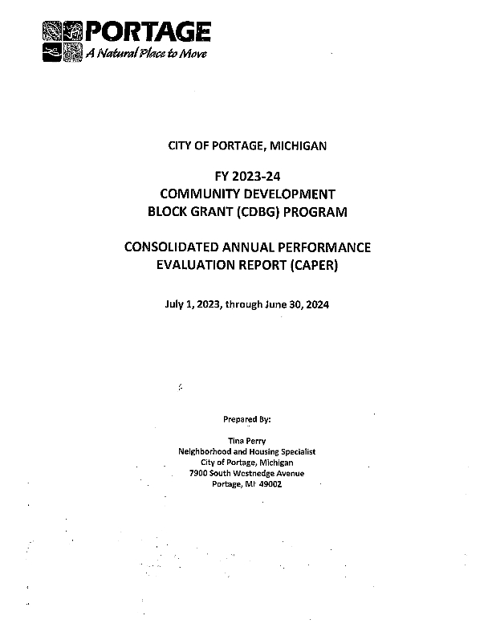
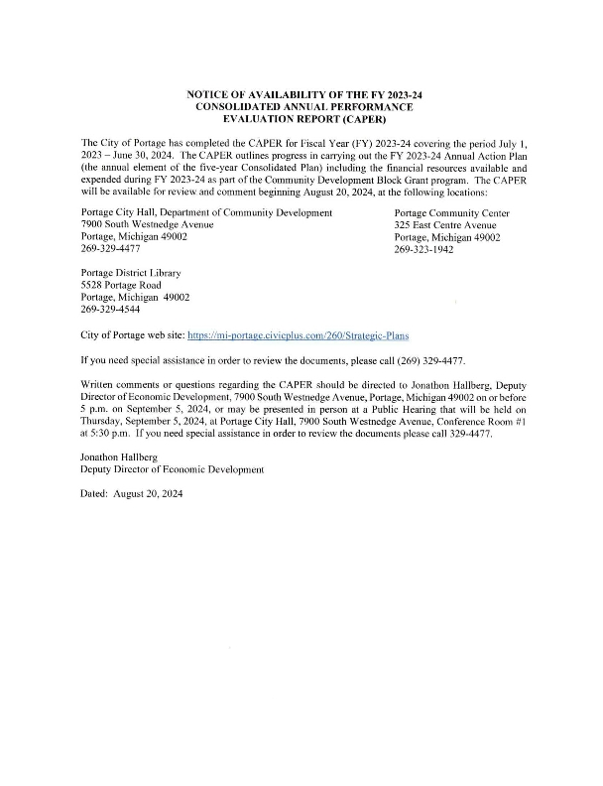

CDBG PR 26
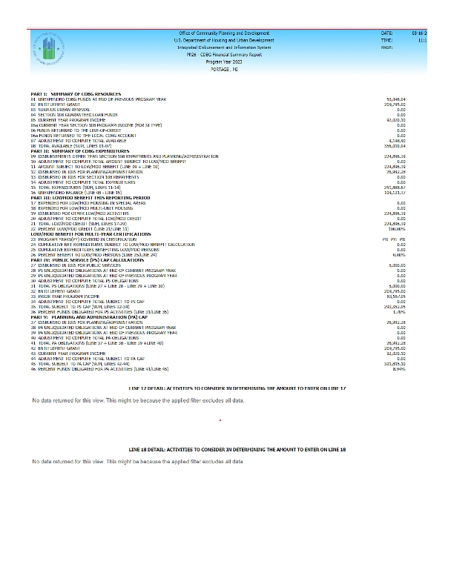
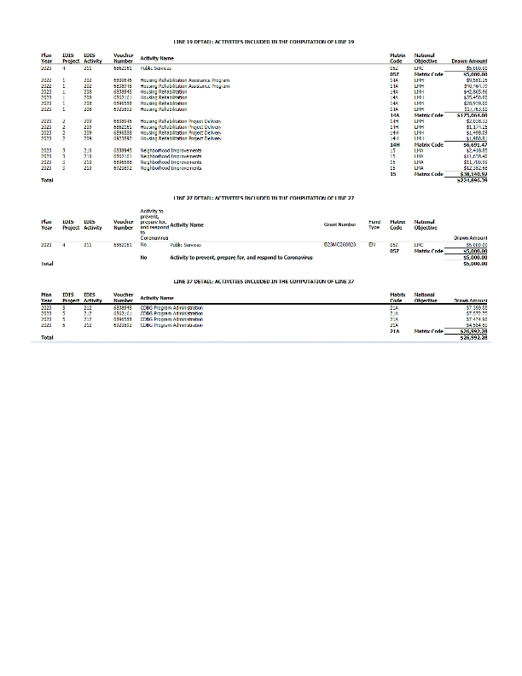

PR-26 CV
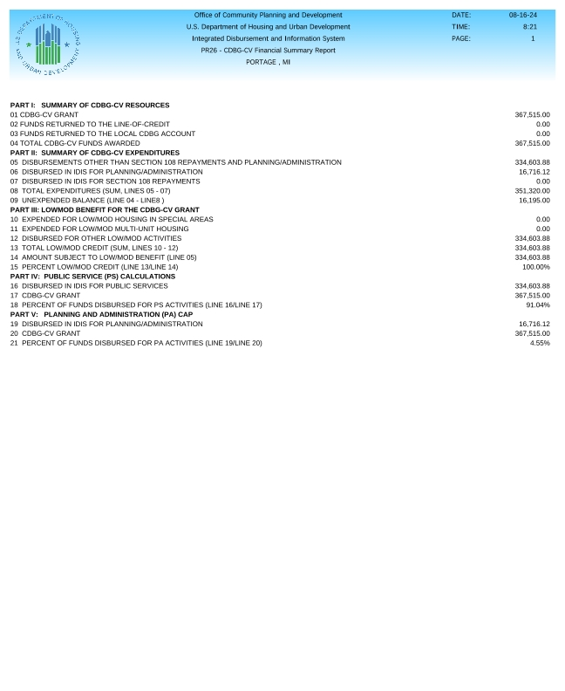
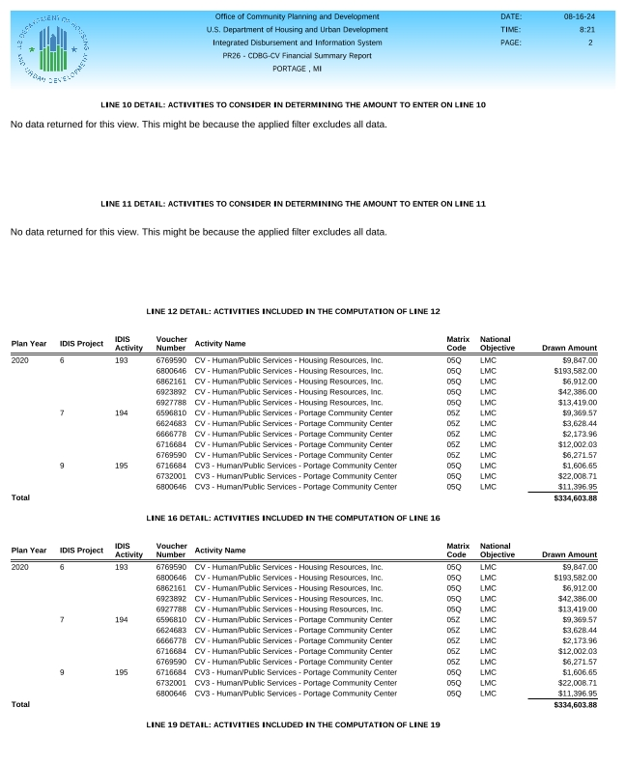
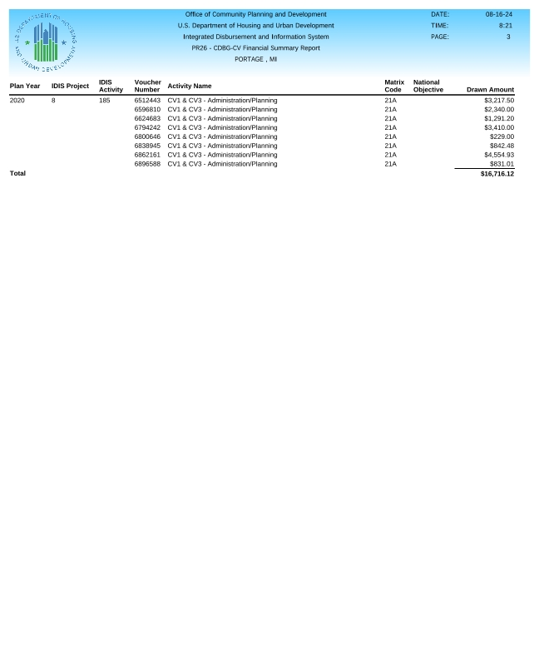

Low Moderate Income Census Map
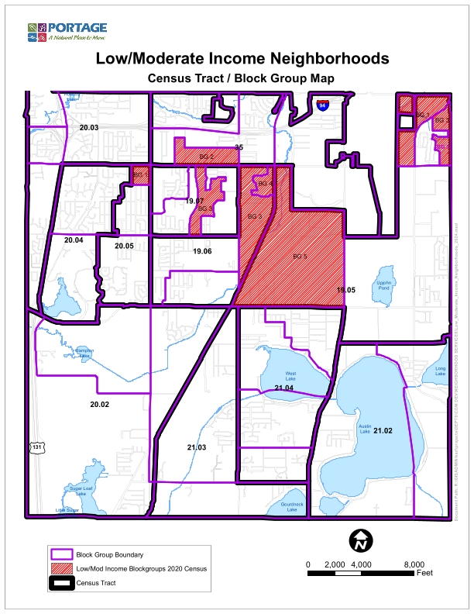

PR-09 PI detail by FY
