CITY OF PORTAGE
FY 2026 – 2027 HUMAN SERVICES FUNDING GRANT APPLICATION

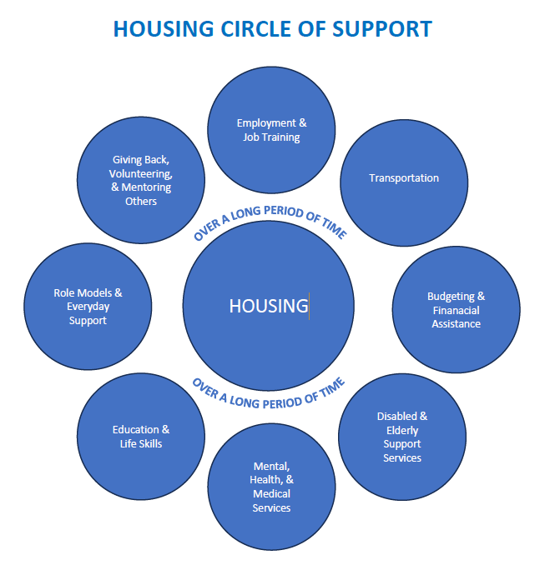

GENERAL INFORMATION
Name of Organization:

Address:

Is the organization an incorporated, not-for-profit organization: Yes No
Is the organization Internal Revenue Service 501(c)(3) classified: Yes No

Name of Board President:

Contact Person:

Phone #: Email:

Web address:

If an applicant is not able to provide the following, it may not be eligible for funding. Please contact City of Portage staff if the answer to any of these questions is No:

- The organization will track the number of Portage residents served? Yes No
- The organization will provide Comprehensive General Liability Insurance and Motor Vehicle Insurance for $1,000,000 per occurrence with the city, its employees, and its appointed and elected officials named as an insured party? Yes No
- The organization will provide a yearly independent audit performed by a Certified Public Accountant? Yes No OR
- If an audit is not required of the organization (preferred), are you able to provide a prior year end financial statement? Yes No

ORGANIZATION INFORMATION
How long has the organization or agency been in existence AND how long has each program for which funding is being requested been in existence:

Please indicate the most recently approved fiscal year total annual budget for your organization and the fiscal year it covered:
Total budget ($) | Fiscal year (e.g., July 1, 2025 – June 30, 2026)
$

GRANT APPLICATION INFORMATION
- Please list the individual programs and requested funding levels from the city:
 | Name of Program | Funding amount requested ($)
 | NOTE: the same program numbers assigned in question #1 carry through to question #4.
1. |  | $
2. |  | $
3. |  | $
4. |  | $
5. |  | $

- Please indicate the specific products/services provided with city funds requested:
1.
2.
3.
4.
5.

2.b. What is the purpose or mission you are using the funds for?
1.
2.
3.
4.
5.

- For the program for which you are seeking funding, please provide the total annual program budget and the percent of that budget being requested from the city:
 | Total annual program budget ($) | Percent (%) of funding requested from city
1. | $ | %
2. | $ | %
3. | $ | %
4. | $ | %
5. | $ | %

- For the program for which you are seeking funding, please indicate the following* for your most recently completed fiscal year (FY) and goals for the upcoming year:
 | Total number of program clients served |  | Total number of Portage residents served |  | Portage residents served as percent (%) of total clients served
 | Prior FY | Upcoming FY | Prior FY | Upcoming FY | Prior FY | Upcoming FY
1. |  |  |  |  | % | %
2. |  |  |  |  | % | %
3. |  |  |  |  | % | %
4. |  |  |  |  | % | %
5. |  |  |  |  | % | %
*Please explain if you are unable to fully track this information:

- The Human Services Board is seeking long-term solutions directly focused on housing. Examples include availability of rental units; ability to obtain homeownership; elderly, assisted, & supportive housing. How does your program/service directly corelate to one of the services above, that supports obtaining and maintaining housing for Portage residents?

- For the programs to be funded, please list other significant sources of funds expected or requested, including specific information (agency name, amount requested and purpose):

- No one organization will provide all services that support housing, though collectively, multiple programs can work toward the greater goal. Utilizing the Circle of Support, explain how your program supports housing and identify which one circle is the best program fit.

- For the programs for which you are seeking funding, describe how Portage residents receive services (i.e. do they visit an office in Portage or where; during what hours; is there 24 hour emergency help? Check all that apply. How accessible are your programs to Portage Residents? (check all that apply):
Services are mobile and immediately available to Portage residents at their location of need.
Services located in Portage and assessable via in an on-site office in Portage.
Services accessible after normal business hours of 8:00 a.m. – 5:00 p.m.
Services available/accessible via public bus routes and/or transportation by an agency
N One of the above:

- How does your organization communicate and collaborate with other agencies to coordinate services that work toward the goal of long-term housing: .

- For the programs for which you are seeking funding, a majority of clients are (1 best answer):

Extremely low income (30% or below of area median income) and/or disabled and/or a victim of abuse and/or other situation
Low Income (80% or below of area median income) and/or senior citizens Client is vulnerable or at risk of becoming of the above
Other (explain):
- For the programs for which you are seeking funding, what ways do you outreach to City of Portage residents? Provide details about the various ways you do outreach, connecting with persons that utilize your program/service(s)?

- Please describe the anticipated long-term sustainability of the programs for which funding is requested:

- As a result of receiving city funding, are you able to leverage to receive other funding for your program/services?

Please attach the following documents for City of Portage review:
- Sample brochure(s) or similar information describing the services offered, particularly services to be funded by a City of Portage grant.
- List of agency Board of Directors, including business and/or organizational affiliation.

Mail/deliver applications by 12:00 p.m. Tuesday, November 25, 2025 (electronic submissions will not be accepted) to the City of Portage Community Development c/o Tina Perry at 7900 S. Westnedge Avenue, Portage, MI 49002.
- Provide an audit if required by the organization, or a prior year end financial statement.
- Financial Statements for most recently completed fiscal year which include revenue and budget information.

Notice to Applicants for Human Public Service Funding:
The City of Portage has adopted a non-discrimination ordinance (see link below). Agencies applying for funding from the City of Portage agree to provide services, programs and assistance consistent with this and all other state and federal regulations regarding non-discrimination for all individuals who may be seeking or receiving services from such agencies. We, as representatives of the agency, agree to comply with all applicable federal, state and local non- discrimination regulations and to provide services to all individuals accordingly. https://www.portagemi.gov/DocumentCenter/View/447/Non-Discrimination-Ordinance-PDF.
“The applicant, and any successor or assign, is required to meet and maintain compliance with all financial obligations to the City and meet and maintain compliance with all applicable federal, state and city codes and ordinances at all times during the term of this contract.”

AUTHORIZED SIGNATURE:I hereby verify that the information presented above is correct to the best of my knowledge.

Name (print or type) Title Date

X

Signature

The application form is available on the city website. FY2026-27 Human Services Funding Grant Application form available on our website at: http://www.portagemi.gov/documentcenter/view/450. Funding will be announced after approval by Portage City Council in the spring of 2026 for use July 1, 2026 – June 30, 2027. If you have any questions contact Tina Perry, Neighborhood & Housing Specialist, at (269) 324-9280.

T:\COMMDEV\2025 2026 Department Files\CDBG\FY 26-27 HPS\Application FY26-27 Human Services Application.docx

